Lesson Six
Charts
- There are many different types of charts, these being;
  - Column charts
  - Bart charts
  - Line Charts
  - Pie Charts

Creating charts
- The first thing you need to do is to create a table with data which you wish to create a chart for.
- Then follow the steps below;
  - Select the whole table of data
  - Click on the insert tab
  - In the chart section you will see all the different types of charts. We will be using the first 4 only

  - Once you click on a chart type a drop down will appear, here you must select which chart you wish to use

  - Once you click on a chart type it will automatically be created and shown on the screen

Change the chart type
- If you wish to change the chart type;
  - Select the chart by simply clicking on its border
  - The ribbon will change
  - Click on the first button ‘Change Chart type’

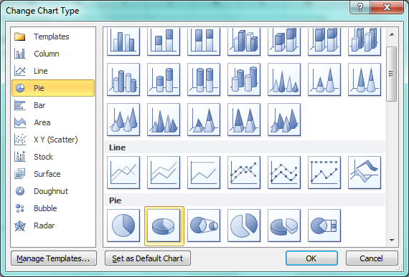
  - Once you click on ‘Change Chart Type’ a new window will open. From this window you would need to select the chart type you wish to use by double clicking on it.

Move, resize, delete a chart
- To move a chart simply click on the border of the chart and drag it to where you like
- To resize a chart
  - Click on the chart
  - Select the format tab
  - On the right had side you will need to write the size you wish
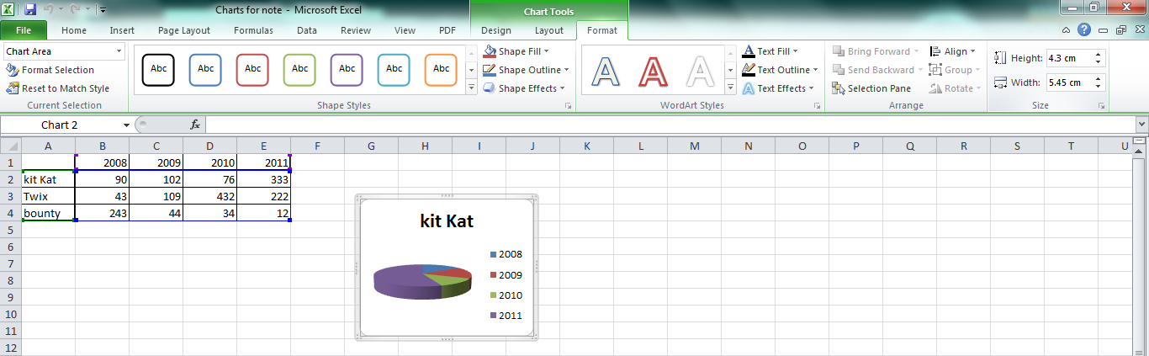
  - To delete a chart just click on the chart and press delete on your keyboard

Add, remove, edit a chart title
- To add, remove or edit the title of a chart
  - Click on the chart
  - Click on the layout tab
  - Select ‘Chart Title’
  - Once you click on ‘Chart Title’ you will have a number of options

Remove title
Centre title

Place title above chart

Edit font, color and style of title

Add data labels to a chart: values/numbers, percentages.
- To add, remove or edit data labels
  - Click on the chart
  - Click on the layout tab
  - Select ‘Data Labels’
  - Once you click on ‘Data Labels’ you will have a number of options

Remove data labels

Centers data labels

Places labels inside/outside chart

Edit values, numbers and percentages

Change chart area background colour
- To change the background colour
  - Click on the chart
  - Click on the layout tab
  - Select ‘Plot area’
  - Once you click on ‘Data Labels’ you will have a number of options, click on ‘More Options’
  - Select fill and click on solid fill and pick a colour

Change the column/bar/line/pie slice colours in the chart
- To change the column/bar/line/pie slice colours
  - Click on the column/bar/line/pie slice you wish to change
  - Click on the format tab
  - Select the fill colour

