Lesson Seven
Change worksheet margins: top, left, right, bottom
- Click on the ‘Page layout’ tab
- Click on the ‘Margins’ button
- When you click on the margins button a drop down list of options will appear

To create your own margins
Default margins
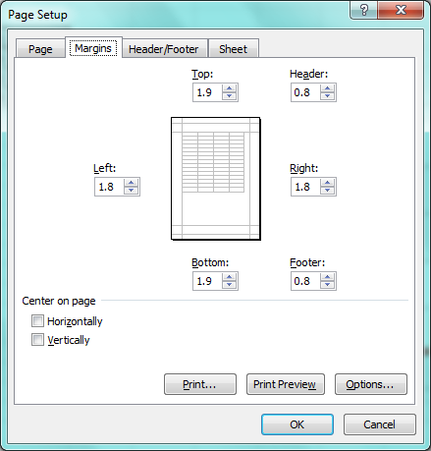

- When you click on ‘Custom Margins’ you will be able to create your own margins by entering the size you wish your margins to be

Change worksheet orientation: portrait, landscape
- Click on the ‘Page layout’ tab
- Click on the ‘Orientation’ button
- When you click on the orientation button a drop down will appear
- Select landscape or portrait

Change paper size
- Click on the ‘Page layout’ tab
- Click on the ‘Size’ button
- When you click on the size button a drop down will appear with a number of option

Default Sizes

To create your own margins

Insert and delete fields to headers/footers
- To insert headers and footers to your worksheet
  - Click on the ‘Insert’ tab
  - Click on ‘Header and Footer’
  - Your page will change and show the header first
  - To move to the footer you have to click on ‘Go to Footer’
- Page numbering
- Click on ‘Page number’
- Date/ time
  - To insert the date click on ‘Current Date’
  - To insert the time click on ‘Current time’

- File name, worksheet name
  - To insert the file name click on ‘File name’
  - To insert the name of the worksheet click on ‘Sheet name’

Turn on, off display of gridlines
- Click on the ‘Page Layout’
- Go to sheet options
- You will find a heading ‘Gridlines’
- Tick the box ‘Print’ if you would like to print the gridlines
- Un-tick the box ‘Print’ if you would not like to print the gridlines

Display row and column headings for printing
- Click on the ‘Page Layout’
- Go to sheet options
- You will find a heading ‘Headings’
- Tick the box ‘Print’ if you would like to print the headings of the columns and rows
- Un-tick the box ‘Print’ if you would not like to print the headings of the columns and rows

Print Preview Options
- Click on the ‘Microsoft button’
- Click on ‘Print Preview’
- A new window will appear with a number of options
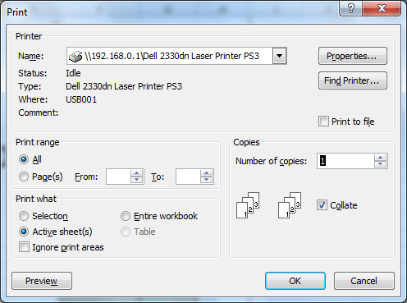
Print a number of copies

Print the whole workbook

Print a selected cell range from a worksheet or a selected area

