Lesson Two
Inserting values
- Click on the cell you wish to add a value to
- Begin to write the value
- When done just press enter

Each cell should contain only one element of data.

Deleting a cells content
- Click on the cell you wish to delete
- Click ‘delete’ or ‘backspace’ and the content will be removed

Selecting a single cell
- Click on the cell you wish to select
- You will know the cell is selected once you see it has a thick black border

Selecting multiple cells
- Click on the cell you wish to start from
- Keep the mouse pressed and drag to the cell you wish
- The cells you select would have a thick black border and also a blue background

Once you select the cells you can copy and paste their content as you would do on MS Word.

Selecting a whole row
- Hover your mouse on the row you wish to select
- Wait till you see the black arrow and click
- The whole row should be selected

Selecting a whole column
- Hover your mouse on the column you wish to select
- Wait till you see the black arrow and click
- The whole column should be selected

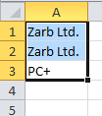
Selecting a whole worksheet
- Hover your mouse on the corner of the worksheet
- Wait till you see the white cross and click
- The whole worksheet will be selected

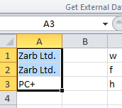
Understanding the name box
- When you select a cell you will see the name of the cell in the name box
- The name box is situated on the top left corner of the worksheet
- If you write a cell name in the name box you will select that cell

Undo and Redo
- These two buttons are used to remove and get back operations done
- They are found on the top left corner of the window
- They are used just like in MS Word

Sorting data
- Select the cells you wish to sort
- Select ‘Data’ on the task bar
- Select ascending or descending order

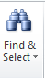
Search and replace
- This is done exactly like MS word
- Click on home and you should find the ‘find & Select’ button on the right hand side

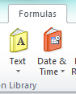
Inserting the Date
- Select Formulas
- Select Date & Time
- Select Date from the drop down list
- Enter the values of today’s date

